**Ispaghula Husk**

**Ispaghula: dried seeds of Plantago ovata F. Plantaginaece.**

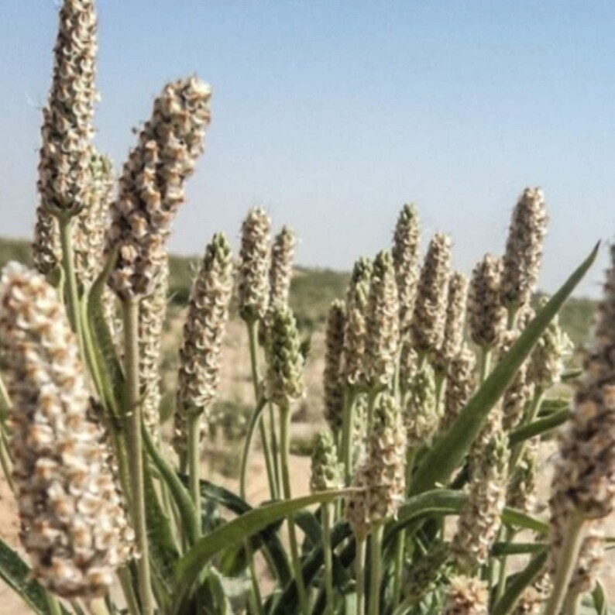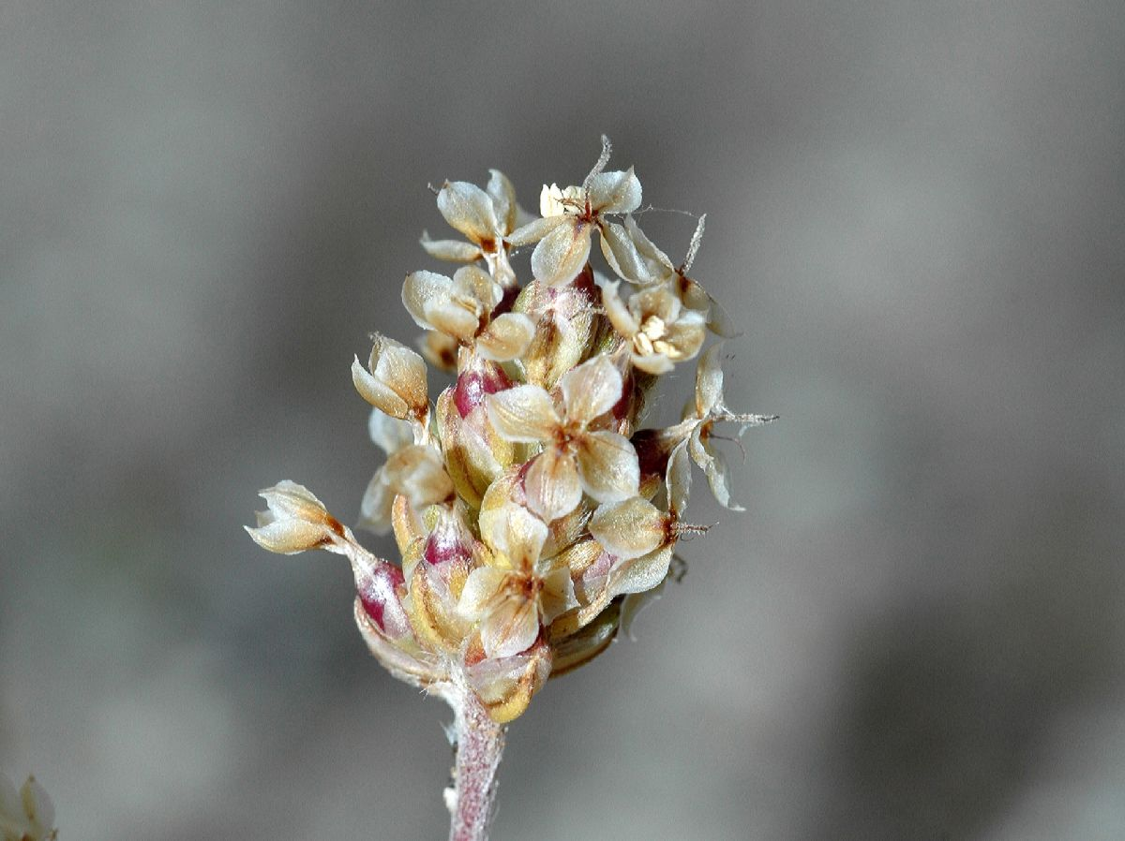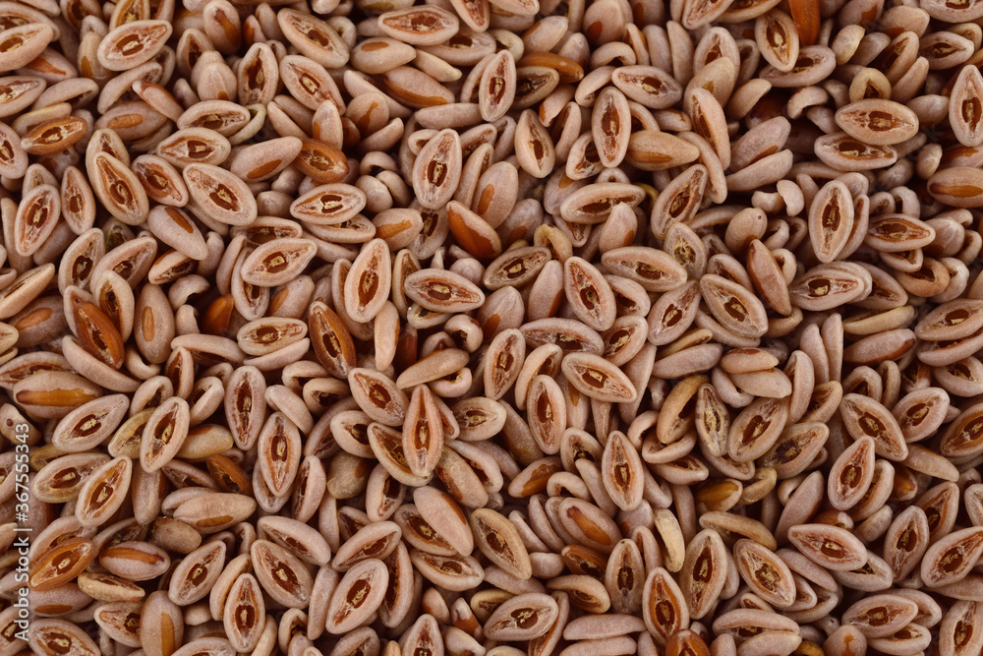

It is an annual herb cultivated in India, Pakistan & Iran.

seeds are planted November. fruits are collected in March/April

Though it is not affected by pests or disease, the yield is decreased greatly due to heavy rainfall or storms.

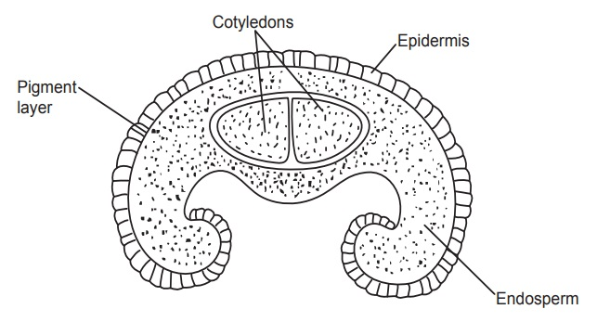

**seeds contain about 10% mucilage (in epidermis of testa).**

**$ Mucilage consists of two complex polysaccharides:**

**✔️ Pentosan:-**

**- soluble in cold water**

**- on hydrolysis yields xylose and arabinose**

**✔️ Aldobionic acid:-**

**- soluble in hot water**

**- on hydrolysis: yields galactouronic acid and rhamnose**

**Chemical Tests:-**

1. **Ispaghula seeds when treated with ruthenium red give red colour due to the presence of mucilage.**
2. **Add water to few seeds on a slide, mucilage comes out and forms zone surrounding the seeds.**
3. **Swelling factor: Swelling factor is the parameter to determine the purity of seeds (it is: 10–13).**

**Adulterants:-**

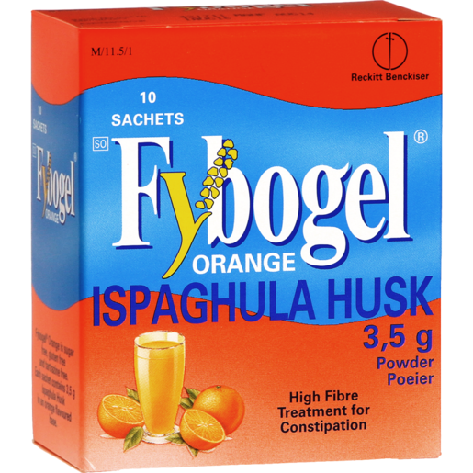

* **P. lanceolata Linn.**
* **P. asiatica.**
* **P. media.**

**Medications:-**

* **Fybogel.**
* **Sat-Isabgol by Dr Morepen.**

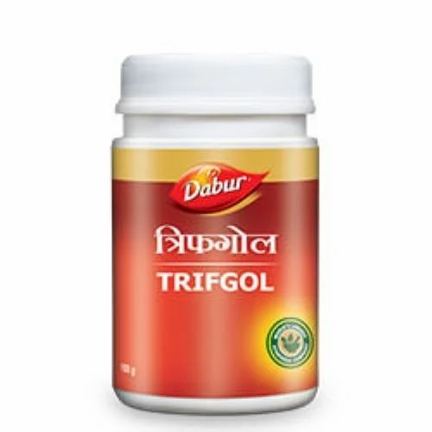

* **Trifgol by Dabur.**

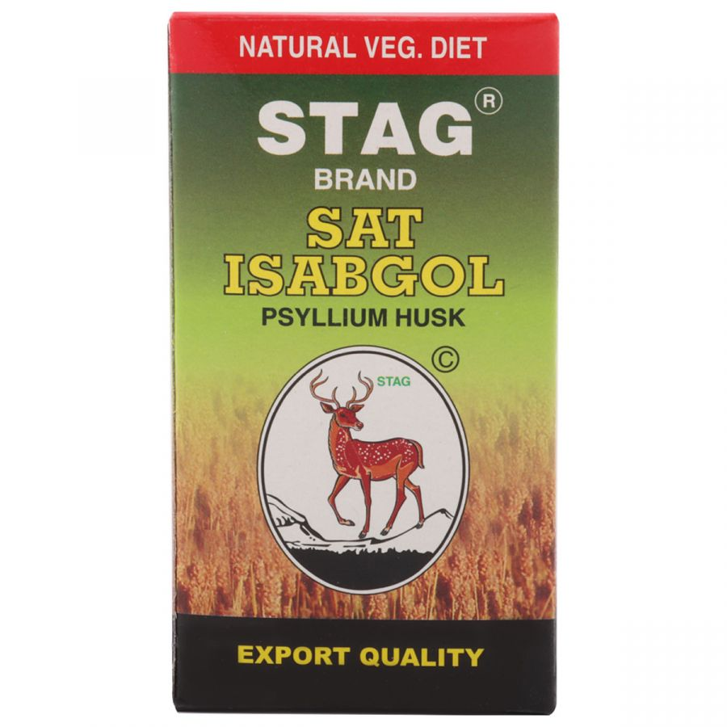

**Uses**

**✔️ Psyllium has been shown to have the paradoxical property of both improving constipation by increasing stool weight and ameliorating diarrhea.**

**✔️ It is also useful in dysentery, chronic diarrhoea, in cases of duodenal ulcers and piles. It works effectively as a soothing agent.**

**Constipation:**

**It is an excellent demulcent and bulk laxative (mild).**

**The laxative activity of ispaghula mucilage is purely mechanical.**

**It is First-line treatment for patients complaining of chronic atonic or spastic constipation and of constipation associated with rectal disorders and may involve the use of osmotic laxatives, lubricating agents, dietary fiber, bulk-forming agents or rectal evacuants the choice depends on whether the clinical context is suggestive of slow transit or evacuation disorders.**

**Diarrhea:**

**Normal intestine delivers stools that defer widely in quantity but maintain percent fecal water within a narrower range.**

**Stools looseness in diarrhea is determined by the ratio of fecal water too water holding capacity of insoluble solids.**

**Psyllium increases the number of normal stools and decreases the number of liquid stools.**

**A combination of psyllium and calcium seems to be cheap and effective alternative to conventional treatment of chronic diarrhea.**

**Fecal consistency was markedly different in psyllium calves as compare with control.**

**Cholesterol lowering:**

**It has been observed that there is a positive association with plasma LDL cholesterol levels and coronary heart disease risk.**

**Intake of dietary fibers known to lower the concentration of LDL in plasma is considered to be highly beneficial.**

**Psyllium intake has consistently shown significant reductions in plasma LDL cholesterol levels ranging from 10 to 24%.**

**Reports of the use of psyllium, largely in hypercholesterolemia men, have suggested that it lowers serum cholesterol as a result of the binding of bile acids in the intestinal lumen and reduced risk of coronary heart disease.**

**The mechanism of action of psyllium’s hypercholesterolemia effects has not been fully elucidated.**

**Psyllium was shown to stimulate bile acid synthesis by increasing the hydroxylase activity in animal and humans models.**

**Irritable Bowel Syndrome (IBS) with Constipation:**

**Constipation is defined as a symptom chronic constipation-based disorder, for at least 3 months in a year for the unsatisfactory defecation and characterized by infrequent stools, difficult stool passage, or both.**

**On the other hand, the presence of clinically important abdominal discomfort or pain associated with constipation defines IBS with constipation.**

**Intake of psyllium may be effective in alleviating chronic constipation in patients without slow colonic transit or disordered constipation. On the other hand, fiber with lactulose may improve stool consistency in patients with IBS with constipation.**

**Personality factors influence the magnitude of therapeutic response of the psyllium.**

**The easing of bowel dissatisfaction appears to be a major reason for the therapeutic success of psyllium in IBS.**

**Ulcerative colitis (Crohn’s disease):**

**The two primary sites for Crohn’s disease are the ileum, which is the last portion of the small bowel (ileitis, regional enteritis), and the colon (Crohn’s colitis).**

**Psyllium maintains remission in ulcerative colitis.**

**Dietary fiber maintains remission in human ulcerative colitis, an effect related with an increased Luminal production of short-chain fatty acids (SCFA).**

**Dietary fiber Supplementation ameliorated colonic damage in HLA-B27.**

**Diabetes:**

**Psyllium is a possible treatment for high blood sugar levels.**

**Moderate reductions in blood sugar levels occurs after a single dose of psyllium, with unclear long-term effects.**

**Watersoluble dietary fibers decrease postprandial glucose concentrations and decrease serum cholesterol concentrations to men with type 2 diabetes.**

**So, it improves glycemic and lipid control in individuals with type-2 diabetes.**

**The ability of soluble fibers to reduce the postprandial glucose response to meals eaten several hours after fiber ingestion (second meal effect) was shown previously in non-diabetic individuals.**

**Drug delivery agent:**

**Ispaghula was found stable in the stomach pH (acidic) than intestinal pH (alkaline) due to comparatively rapid swelling in alkaline pH than acidic pH.**

**In the intestinal environment, where the concentration of monovalent ions (e.g., Na+, K+) is higher and exceeds the concentration of multivalent metal cations (e.g., Ca2+, Al3+). Therefore, these ionotropic-gels tend to lose their stability over the term due to diffusion leading to exchange of multivalent metal cations for monovalent ones, which results faster and premature release of encapsulated drugs from ionotropically-gelled GG particulates in intestinal pH.**

**Hydrogels, specially based on polysaccharides, are excellent controlled release devices or targetable devices of the therapeutic agents.**

**The release rate of drugs from hydrogels was primarily determined by the swelling extent, which further enhanced by addition of enzyme in the buffer solutions.**

**The loading of a drug onto hydrogels matrix was carried out by swelling equilibrium method.**

**The hydrogel was allowed to swell in the drug solution of known concentration for 24 h at 37C and then dried to obtain the release device.**

**The concentration of the rejected solution was measured to calculate percent entrapment of the drug in the polymer matrix.**

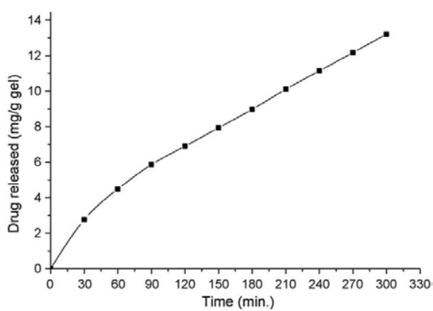

**Side effect**

**✔️ Flatulence and bloating (due to degradation of polysaccharides by large intestinal flora) may occur with the use of the product, which generally disappears in the course of the treatment.**

**✔️ Abdominal distension and risk of intestinal or oesophageal obstruction and faecal impaction, particularly if swallowed with insufficient fluid (this also happens with overdose).**

**✔️ Due to the allergic potential of Ispaghula, patients must be aware of reactions of hypersensitivity including anaphylaxis-like reactions (eg: bronchospasm) very rarely.**

**Mechanism of Action**

**✔️ Pharmacotherapeutic group:**

**Laxatives – Bulk Producers, other Cholesterol and Triglyceride Reducers.**

**✔️ Ispaghula absorbs water and makes the stool soft and bulky, easier to pass.**

**It has mucilage higher than other Plantago species.**

**It is capable of absorbing up to 40 times its own weight in water.**

**It consists 85 % water-soluble fiber, it is partly fermentable (invitro 72 % unfermentable residue) and acts by hydration in the bowel.**

**The pharmacological effects is mechanical stimulation of the gut wall depending on the increase in intestinal bulk by water and the decrease in viscosity of the luminal contents.**

**When taken with a sufficient amount of liquid (at least 30 ml per 1 g of herbal substance), it produces an increased volume of intestinal contents due to its highly bulking properties and hence a stretch stimulus which triggers defaecation.**

**At the same time the swollen mass of mucilage forms a lubricating layer which makes the transit of intestinal contents easier.**

**In mild to moderate hypercholesterolemia a reduction of serum cholesterol of approximately 5 % is reported in literature.**

**Contraindications**

* **Ispaghula husk is not to be used by patients with a sudden change in bowel habit that persists for more than 2 weeks, undiagnosed rectal bleeding and failure to defaecate following the use of a laxative.**
* **Ispaghula husk is also not to be used by patients suffering from abnormal constrictions in the gastro-intestinal tract, with diseases of the oesophagus and cardia, potential or existing intestinal blockage (ileus), paralysis of the intestine or megacolon, diabetes mellitus, which is difficult to regulate.**
* **Patients with known hypersensitivity to Ispaghula husk should not use Ispaghula husk preparations.**

**Drugs interactions**

**✔️ Whenever you take more than one medicine, or mix it with certain foods or beverages, you are at risk of a drug interaction.**

**Alcohol: Using alcohol while taking this drug is not recommended. Any activity requiring a high level of mental alertness should be avoided in such cases.**

**Interaction with Medicine: Ispaghula decreases absorbtion so, it decreases effect of warfarin, digitalis, potassium-sparing diuretics, salicylates, tetracyclines, nitrofurantoin.**

**Interaction with Disease: Inform your medical practitioner if you have a history of appendicitis or a blockage in your bowel.**

**May contain aspartame which is metabolized in the GI tract to phenylalanine which is contraindicated in individuals with phenylketonuria.**

**Use with caution in patients with esophageal strictures, ulcers, stenosis, or intestinal adhesions.**

**Interaction with Food: Should be administered with large amount of fluids (to avoid intestinal blockage).**

**Herbal medicinal product**

**✔️ For the treatment of habitual constipation.**

**✔️ In conditions in which easy defaecation with soft stools is desirable, e.g. in cases of painful defaecation after rectal or anal surgery, anal fissures and haemorrhoids.**

**✔️ In patients to whom an increased daily fibre intake may be advisable e.g. as an adjuvant in constipation predominant irritable bowel syndrome, as an adjuvant to diet in hypercholesterolemia.**

**Safety**

**✔️ It is not mutagenic or carcinogenic, but may cause hypersensitivity.**

**✔️ Unlike Senna, Ispaghula is not addictive.**

**✔️ You can drive while using Ispaghula.**

**✔️ Pregnancy and lactation: Although No restriction (Bulk producers should be used before using other purgatives if change of nutrition is not successful.), but pregnant and Lactating women are advised to consult a doctor before consuming this drug.**

**✔️ Ispagula is approved in India, United States & Japan.**

**Method of administration**

**Mix approximately 1 g of the herbal substance with at least 30 ml of water, milk, fruit juice or other liquid; stir briskly and swallow as quickly as possible. Alternatively the herbal substance can be taken and swallowed with sufficient quantity (at least 30 ml per g of herbal substance) of water, milk, fruit juice or other liquid; then maintain adequate fluid intake.**

**Progress of action: Ispaghula husk usually acts within 12 to 24 hours after single administration. Sometimes the maximum effect is not reached for 2 or 3 days.**

**Duration of effect: depends on individual and dosage.**

**Dose: one dose per day up to 2 weeks.**

**Warnings:**

**✔️ In case of overdose: seek medical help immediately.**

**✔️ Do NOT take this drug immediately prior to bedtime.**

**✔️ Take Ispaghula after a gap of two hours from other medicines, as it may slow the enteric absorption of other medicines (eg: drugs for kidney or liver) and thyroid hormones.**

**If the product is taken together with meals in the case of insulin dependent diabetics it may be necessary to reduce the insulin dose.**

**✔️ If used for constipation: not for children less than 6 years.**

**✔️ If used for hypercholesterolemia: not for children less than 12 years.**

**✔️ Take this product with at least 150 ml of water or other fluid.**

**Taking this product without adequate fluid may cause it to swell and block your throat or oesophagus and may cause choking.**

**Intestinal obstruction may occur should an adequate fluid intake not be maintained. Do not take this product if you have ever had difficulty in swallowing or have any throat problems.**

**If you experience chest pain, vomiting, or difficulty in swallowing or breathing after taking this product, seek immediate medical attention.**

**The treatment of the debilitated patient requires medical supervision.**

**The treatment of elderly patients should be supervised as they have insufficient fluid intake which may predispose them to faecal impaction and bowel obstruction.**

**Some advice:**

**✔️ You are advised to eat more fibre in your diet.**

**✔️ Also, drink 8 to 10 glasses of water every day.**

**✔️ Exercise for at least 3 times per week.**

**✔️ You must not hold in stool as that can worsen bowel issues.**

**~: References :~**

* **https://www.globalresearchonline.net/journalcontents/v18-1/08.pdf**
* **https://www.ema.europa.eu/en/documents/herbal-monograph/draft-community-herbal-monograph-ispaghula-husk-plantago-ovate-tegumentum_en.pdf**
* **https://www.pharmacy180.com/article/ispaghula-111/**
* **https://www.lybrate.com/medicine/ispaghula**
* **https://www.sciencedirect.com/science/article/abs/pii/S014486171400143X**